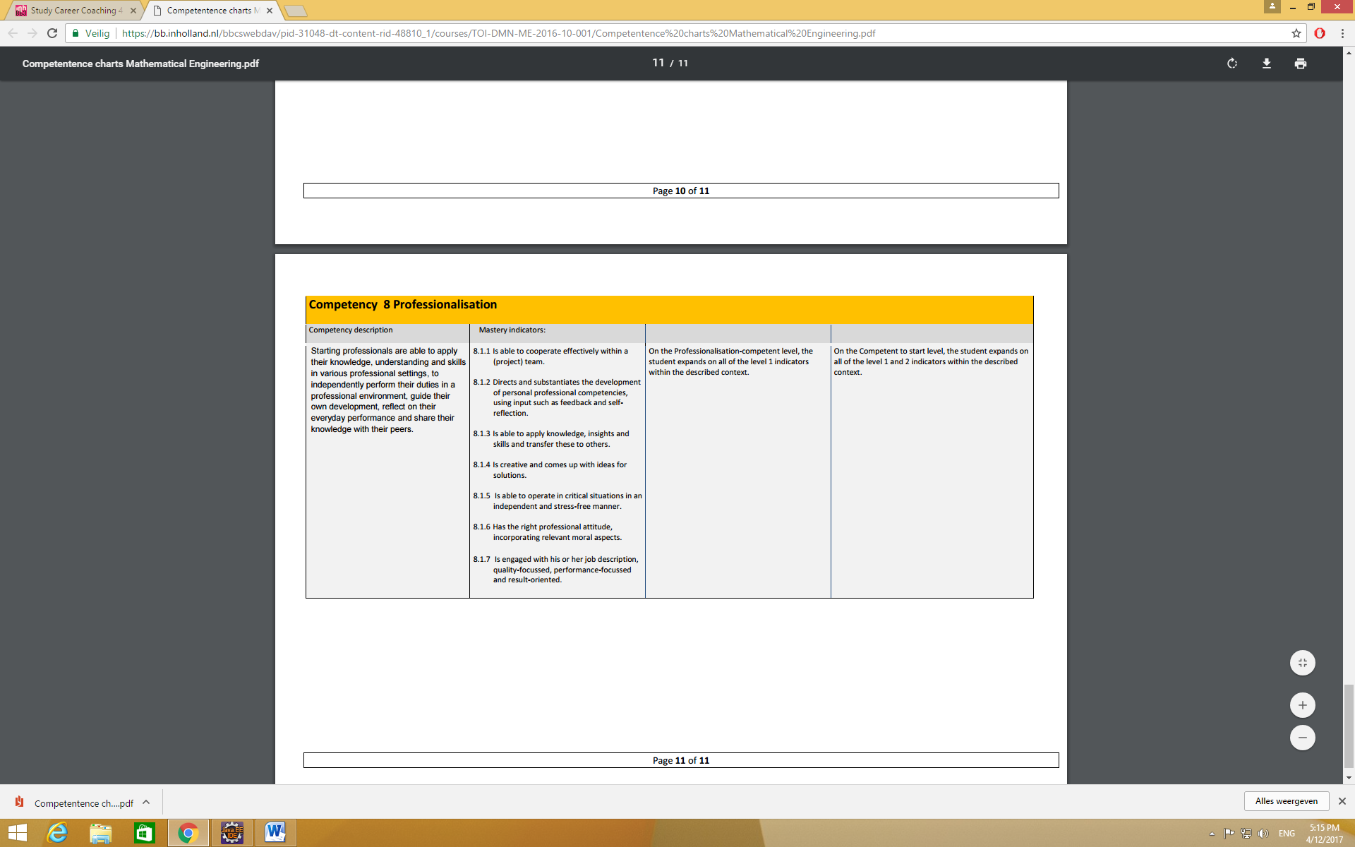STARR table proofing professionalization competence

8.1.4 Is creative and comes up with ideas for solutions.

# Situation:

* What was the situation?
* What happened?
* What was the occasion?
* Who were involved?
* When was it?
* How long?

# Task:

* What was your task?
* What was your role?
* What did you hope to achieve?
* What did others expect of you?
* What did you expect of you?
* What did you think should happen?

# Action:

* What did you hear/say/feel?
* How did you react?
* How did you handle it?
* How did the others react?
* What did the others hear/say/feel according to you?

# Result:

* What was the result?
* What was the reaction of the others to this result?

# Reflection

* Are you happy with the result?
* Are you happy with your actions?
* What did you learn?
* What will you do different next time?
* What do you need for that?
* Can you apply what you learned in other situations?